2018
Annual Statement on Research integrity
company name
St GEorge’s, University OF LONDON

Annual Statement on Research Integrity 2018

Commitment to Integrity
Encouraging and ensuring integrity in research is central to St George’s, University of London’s (SGUL’s) research mission, and various systems and processes are in place to uphold research integrity. . SGUL fully supports the principles documented in ‘The Concordat to Support Research Integrity’.
SGUL’s 2017-22 strategic plan states that SGUL believes in acting with integrity in all of our interactions, and defines our core values as openness, respect, engagement and commitment.
This document outlines the approach which embeds practices that support research integrity and ethical behavior, across the numerous functional areas of SGUL which support research integrity. Also included in this report are details of our research misconduct and whistleblowing policies and our research integrity webpage.

Joint research & enterprise ServiceS
The Joint Research and Enterprise Service (JRES) is the official research governance and management oversight function for St Georges, University of London and St George’s University Hospitals NHS Foundation Trust. The JRES is responsible for ensuring that any research involving humans (including their tissue and data) is conducted according to appropriate ethical, legal and professional frameworks, obligations and standards. It has a suite of standard operating procedures (SOPs) and guidance documents to ensure a robust research governance and ethics framework is in place, which aims to ensure that all human subject research is subjected to an appropriate level of ethical and organisational scrutiny. These SOPs are maintained online for ease of access and are regularly reviewed to ensure processes, roles and responsibilities are updated and in line with organisational expectations. The JRES provides training sessions through various programmers throughout the university, both online and face-to-face, which support our researchers and students to conduct their research within scope of the various legislative requirements.
A wide range of education, training provision, communication and awareness raising activities are undertaken across the university. Each research theme has a Research Governance and Facilitation Officer to support researchers in developing clinical study protocols, documentation and maintaining ethical standards against national Health Research Authority (HRA) guidance and legislation. For non-clinical HRA projects and student based research the JRES Research Ethics Officer has the responsibility of ethics approval, raising awareness of and providing training on research ethics, writing annual monitoring reports for Research Ethics Committees and keeping stakeholders informed about the national and university policy on research ethics.

GOVERNance, legal and assurance services
The Governance, Legal and Assurance Services Team (GLAS) supports the effective governance of SGUL as a whole. GLAS works to ensure that effective decision-making structures are in place and have oversight of a wide range of areas that contribute to the integrity of research, including risk management, freedom of information, safety management, records management, and legal services. GLAS provides advice and training on these areas to staff across the institution.
GLAS ensures the effective operation of the following policies, which enable stakeholders to have confidence in the outputs of our research at SGUL:
- Anti-Fraud Policy
- Freedom of Information Policy
- Records Management Policy
- Retention and Disposal Policy
- Retention Schedules
- Whistleblowing and Public Interest Disclosure Policy and Procedure

GLAS is currently developing a new policy on digital preservation in order to manage risk in relation to records held in a digital format and are in the process of reviewing the Whistleblowing and Public Interest Disclosure Policy and Procedure to ensure it is fit for purpose.
As part of an ongoing review of university governance, GLAS is currently undertaking an exercise to better understand how laboratory data at SGUL is recorded, managed, stored, and retained. GLAS supports best practices to help researchers better manage and archive their laboratory data.

Library
The library supports research at SGUL across much of the research lifecycle (see diagram below).
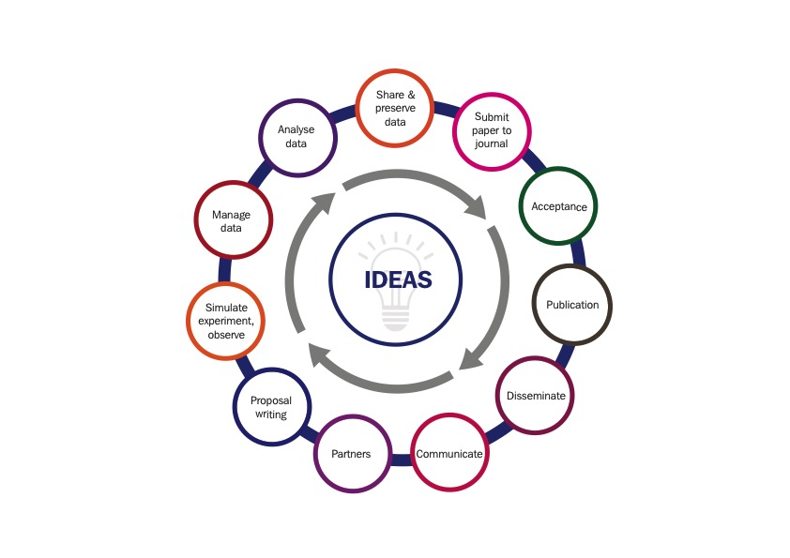
There is support, training and 1:1 guidance for searching the literature, appraisal of papers, managing references and avoiding plagiarism.
The library are fostering practices around open science to enable wider communication, collaboration, and reuse of our research.
Funder mandates, publisher policies and other initiatives around open access to research publications and responsible research data management are areas of constant evolution. The library encourages, through the Scholarly Communications Group and Research Data Management Working Group, input from colleagues in JRES, and academic and administrative representatives from our research institutes, to promote institutional understanding, and transparency in decision making processes. Our Research Publications Policy and Research Data Management Policy outline the expectations on researchers and the assistance available to support them.

Research Publications
The library makes available for our researchers a Current Research Information System (CRIS) to capture securely details of their research publications; this system is from a well-established research information software provider (Symplectic), which is committed to support and develop the system capabilities. The CRIS is linked to our institutional repository for publications, St George's Online Research Archive (SORA) which is hosted and supported by Cosector, specialists in research software platforms. Using open source software, this makes researchers publications available freely online, allowing open scrutiny and reuse of research findings.
The Research Data Management Service oversees research data management (RDM) and data sharing activities across the university. The service is tasked with advocating and embedding a culture of responsible data management and sharing across the institution. It achieves this by:
- Supporting the implementation of SGUL’s Research Data Management policy.
- Establishing advocacy programmes to raise awareness of good data management and responsible data sharing.
- Implementing skills development and training programmes to equip our researchers with knowledge and practical skills in handling and sharing data according to community and professional standards, especially in our current data intensive research landscape.
- Partnering with related services, such as research computing services, information governance, data protection and records management to deliver integrated research data services that comply with legal, institutional, regulatory and funder obligations and standards.
- Providing adequate infrastructures to enable high quality, responsible data sharing; including managing our (pilot) institutional data repository and preservation system and administering our controlled data access procedures, which together ensure that SGUL research is open and transparent and preserved for the long term.
- Supporting SGUL’s data quality requirements for the NHS Data Security and Protection Toolkit.
- Working closely with the wider RDM community to embed emerging good practice at SGUL and ensure that we are consistently working to the highest standards in how we handle and share data.

Biological Research Facility
The Biological Research Facility (BRF) has an important research integrity role in maintaining the highest possible standards of animal welfare, ensuring best practice is followed and adhered to, by all academics/researchers and support staff working within the BRF. The conditions and standards for this are governed by the UK Home Office who have a specialized unit, the Animals in Science Regulation Unit (ASRU) https://www.gov.uk/guidance/research-and-testing-using-animals
The BRF’s policy is to actively promote and adopt NC3R’s recommendations which is done via the systems BRF has in place, to meet the regulatory requirements of The Animals (Scientific Procedures) Act 1986 (ASPA). https://www.nc3rs.org.uk/
As part of the legal requirements of ASPA, the ethical and animal welfare aspects of scientific integrity are governed through an internal committee– the Animal Welfare & Ethical Review Body (AWERB). Before any use of animals for scientific procedures can commence, academics discuss proposals with BRF management to ensure that full consideration of resource requirements, legal compliance and appropriate funding are in place. Then full proposals are submitted for AWERB consideration/approval prior to submission for final approval by the Home Office.
Culture of Care (CoC) is actively pursued within the BRF with the aim of providing an inclusive, helpful and blame free environment that helps encourage good science and openness.
BRF has a thorough induction programme for all persons that require to undertake animal based research procedures within the BRF. This covers extensive topic areas to promote good science and integrity. Until the induction process is satisfactorily completed, people are not able to have unsupervised access. Following successful induction process, the BRF maintains intensive training and competency assessment records for each individual.
SGUL was an initial signatory to the Concordat on Openness on Animals in Research in 2014. Since then, with governance aspects managed by the BRF, SGUL actively engages and contributes to the four commitments under the Concordat. In connection with the Concordat, the BRF maintains SGUL membership and proactively engages with Understanding Animal Research (UAR) http://www.understandinganimalresearch.org.uk/

ethics Committee
Over the 2017-2018 academic year the St Georges Research Ethics Committee (SGREC) reviewed 42 research applications. The SGREC annual report 2018 covers the reporting period of the previous academic year September 2016 to August 2017. In that time the committee reviewed 26 applications. Most applications were given an ethics review by the research institutes, which is our fast-track approvals system. To ensure that robust reviewing of ethics applications occurs, ongoing training activities for committee members is arranged.
SGUL has aligned the role of Research Integrity Lead with the Chair of the Ethics Committee. In that capacity, informative training for all university employees on the Concordat to Support Research Integrity has been facilitated with sessions on the university’s quarterly welcome seminars for new staff. Further, less experienced academic staff and postgraduate students receive integrity training annually.

Graduate School
Workshops on research integrity are included within the Graduate School skills programme, which is compulsory for research degree students and our Common Postgraduate Framework of modules. These are attended by students from multiple taught postgraduate courses in addition to research degree students. As well as research integrity, these modules include lectures and tutorials on statistics, research methods and public engagement and are also open to clinical academic trainees. The research degree student handbook includes a section on research integrity, which outlines SGUL’s commitment to the ‘Concordat to Support Research Integrity’.

Research Misconduct
Our Research Misconduct Policy and Procedure identifies a senior member of staff in both SGUL and in the St George’s University Hospitals NHS Foundation Trust (with which we share the same campus). Within the university, the key member of staff who oversees research integrity and is the first point of contact is the Deputy Principal for Research and Enterprise and within the trust it is the Medical Director.
The procedure describes the principles by which allegations of research misconduct are processed and judged, thereby ensuring that investigations are carried out in a transparent and fair manner.
Misconduct cases within reporting period
Misconduct Type | Referred for full investigation (Y/N) | Reported to Council (Y/N)
Data handling | N | N

In 2018, there was one allegation of research misconduct that went through the internal informal process. It was brought by a member of staff who suggested that a researcher had acted unprofessionally in handling clinical data. The case was carefully investigated by the Deputy Principal for Research, then Professor Mark Fisher. The allegation of research misconduct was not upheld (report completed in August 2018).
The point of contact in the University for Whistleblowers is Professor Deborah Bowman, Deputy Principal for Institutional Affairs. Our Whistleblowing and Public Interest Disclosure Policy and Procedure is available on the St Georges University website.
In terms of external engagement, St George’s has continued its subscription to the UK Research Integrity Office, a charity offering advice and guidance to universities, students and staff on matters of research integrity.

Research Integrity Webpage
During the 2018 period the university has undertaken a project to redevelop its website. The university will create a webpage covering research integrity and bringing together all of the information on the current website relating to research integrity (for example the Research Misconduct Procedure and research integrity annual statements).. This is in alignment with both government and research funders’ attitudes towards strengthening research integrity. This page is currently under construction so will be reported on in future statements.

Relevant Policies
- Anti-Fraud Policy
- Freedom of Information Policy
- Records Management Policy
- Retention and Disposal Policy
- Whistleblowing and Public Interest Disclosure Policy and Procedure
- Research Publications Policy
- Research Data Management Policy
- Research Misconduct Policy and Procedure
- Anti-Corruption Policy
- Anti-Corruption Statement
- Conflicts of Interest and Financial Dealings Policy
- Gifts and Hospitality Policy
- Donations and Gift Acceptance Policy
- Anti-Fraud Policy
- Data Protection Policy
- Intellectual Property Policy
- Use of Animals in Research Policy

Named Contact for Misconduct: Professor Jon S Friedland, Deputy Principal (Research & Enterprise)
Named Contact for Whistleblowing: Professor Deborah Bowman, Deputy Principal (Institutional Affairs)

