NOVEMBER 2021 Newsletter

Welcome to new STAFF
INSTITUTE FOR
INFECTION &
IMMUNITY

Events

December 8
Research Day

SAFETY AT WORK

Report any safety hazards at work. Log the fault by contacting estates and facilities helpdesk
Ext 1234 option 2 or e-mail: estates@sgul.ac.uk

Travelling on Business
Record all business travel in MyWorkplace under ‘other absence’ to ensure you are covered on your business trip AND you must complete the travel certificate for each travel occasion and email the completed form prior to the start date

Reporting Data Breaches
You can find the Data Incident Reporting Form here

Monthly Deadlines

Expenses Claims:
7th March 2018

Welcome to the following staff who joined us recently:

Dr Hasina Hannan Clinical Research Fellow for Paul Heath
Sinduja Sivarajan, Clinical Trial Manager for Paul Heath
Hsiang-Te Tsai, Research Data Analyst for Yingfen Hsia/Mike Sharland
Sasmita Upadhyaya, Technician for Paul Heath

Welcome to the following PhD students:
- Aurora Campagna
The role of γδT cells in the infiltration and destruction of prostate tumour organoids
Supervisors: Mark Bodman-Smith and Ferran Valderrama
- Emily Carr
The impact of Vitamin D supplementation on immune responses to respiratory pathogens in older children in Zambia with perinatally-acquired HIV-1 infection
Supervisors: Derek Macallan, S Filteau
- Zack Croxford
Engineering cancer immune checkpoint inhibitors for optimal expression and performance
Supervisors: Audrey Teh, Julian Ma
- Ramla Cusman
Investigating metabolic pathways that drive tissue remodelling and fibrosis in Tuberculosis
Supervisors: Jon Friedland, Deborah Chong, Rajko Reljic
- Artemis Papacosta
Therapeutic gene editing of CFTR: Identifying efficiency levels required for functional correction of the CF epithelium by gene editing
Supervisors: Debbie Baines, S Hart
- Sophie Webb
MD(Res) Development of an affordable point-of-care test for HPV DNA cervical cancer screening and reducing barriers to cervical cancer screening through patient self-sampling
Supervisors: Sanjeev Krishna, K Hayes, Henry Staines

All new starters should read the Institute Induction for New Staff via the following link:
https://www.sgul.ac.uk/about/our-institutes/infection-and-immunity/information-for-staff

NOTE:
All supervisors should inform me, Melanie Monteiro, of the room numbers new staff and PhD students will be working in to ensure that the space allocation spreadsheet is kept up-to-date. Similarly, for leavers.

MANDATORY Training

You are all encouraged to complete your mandatory training and ensure it is kept up to date. There is list of the mandatory training requirements at the end of this newsletter

Mandatory training completion rates are monitored by SGUL.

Register for Research Day 2021

Research Day 2021 takes place on Wednesday, 8th December. Research Day is an annual event to showcase the world class research done at St George’s, University of London. It will be a hybrid event. Poster presentations will take place in the boardrooms and Alistair Hunter room.

The Thomas Young Lecture this year will be given by Dame Anne Johnson and is called People, policy and pandemics.

You can view the full schedule for Research Day 2021 here

You are all encouraged to register to attend the day, please click here.

PDR Training for Reviewers and Reviewees

In anticipation of the next PDR round which will run from 1st January 2022 to March 2022, training is available for reviewers and reviewees.

Booking is through My Workplace under Career and Development.
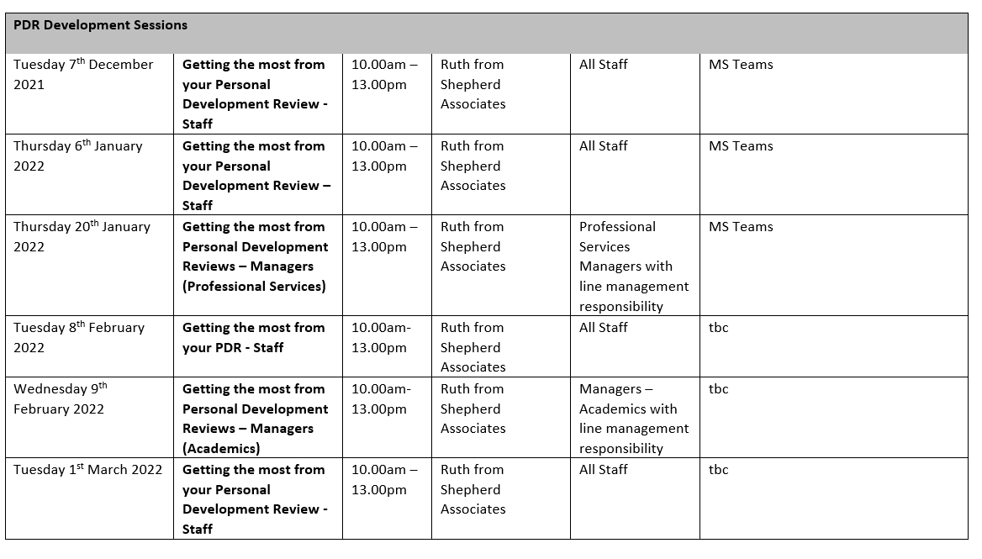

N- Mentor Launch event Tuesday 30 November

St George’s is continuing to participate in B-MEntor Professional, a cross-institutional mentoring scheme for black, Asian and Minority Ethnic staff in Professional Services roles. We are encouraging staff to participate as a mentee or as a mentor for this upcoming round of the programme, beginning in the New Year.
This mentoring programme is run by UCL and various other London-based Universities participate
Applications are now open, further information on how to apply, including induction dates and application deadlines, is hosted on the UCL B-MEntor webpage.
We will be holding a B-MEntor launch event on Tuesday 30 November at 12:30 – 14:00 on MS Teams. This will be an opportunity for staff to hear more about the scheme, what opportunities participating as a mentee or a mentor can bring, and to have the space to ask any questions you might have.
There will also be the chance to hear from staff who’ve previously been part of B-MEntor as mentees or mentors.
To sign up to attend this launch, please email Liz Grand, Diversity and Inclusion Adviser (lgrand@sgul.ac.uk)
Find out more about B-MEntor here.
Liz Grand
Diversity and Inclusion Adviser

CENTRAL SUPPORT UPDATES

Starters and Leavers
STARTERS:
- Nia Watkins, MCS Research Institute Manager, Research Operations start 1 November 2021
- Jacqueline Marks, Head of Administration and Executive Officer to Deputy Principal (Research and Enterprise), Maternity cover, Research Operations
- Terry Turner, Senior Technician (Equipment maintenance), Research Operations start early November 2021
- Shahib Uddin, Senior Governance Officer (Risk Management), Governance Lega & Assurance
- Emma Whitaker, Senior Governance Officer (Corporate and Executive Governance)
- Kayode Ajakaiye, Finance Assistant, Student Union
- Fiorelli Fioretto, Head of Medical Programmes Administration
- Aysha Choudhury, Research and Enterprise Contracts Manager

LEAVERS:
- Tom Muzyka, Research Funding Officer, 13th October 2021
- Lauren Terry, Senior Technician, Research Operations, 3 November 2021
- Katherine Piggott, Head of Medical Programmes Administration

INSTITUTE STATUTORY REQUIREMENTS

Note: Individuals applying for institute funding will need to demonstrate they are compliant and up to date with requirements if they wish to apply for institute funding such as personal staff development funds.
Exceptions would be considered by the Director of the Institute.
Statutory Requirement | Frequency | Indicate you are up to date and include year of completion
Health & Safety –Biological Agents Form | Annual requirement  Queries to the SHE Office
Health & Safety –COSHH Forms | Annual review for Hazard 3 agents & 2 yrs for others  Queries to the SHE Office
Health & Safety – Fire Safety | Annually  Health & Safety E-learning Platform  If you cannot access site, contact the SHE Office
Health & Safety – Display Screen Assessment | Annually  Health & Safety E-learning Platform
Display Screen Equipment e-Learning | Annually  Health & Safety E-learning Platform
General Health, Safety and Environmental Awareness | Every 2 years  Health & Safety E-learning Platform
Manual Handling | Every 3 years  Health & Safety E-learning Platform
Diversity in the Workplace | Every 3 years  Learnupon Platform  Queries to Liz Grand
Unconscious Bias | Every 3 years  Learnupon Platform  Queries to Liz Grand
Prevent Duty Training | Every 2 years  https://canvas.sgul.ac.uk/  Queries to  Elizabeth Okona-Mensah
Information Governance data awareness  (IG Toolkit) | Annually  https://canvas.sgul.ac.uk/  Access queries to lts@sgul.ac.uk
Time Allocation Survey (TAS) | Annually  (Academic HEFCE funded staff /or do teaching)
ORCID Number | Only single registration required (Essential for PhD students & upwards or where relevant)

If you have any item to add to the newsletter, please contact me, Melanie Monteiro.

Melanie Monteiro
Research Institute Manager
Institute for Infection & Immunity

https://www.sgul.ac.uk/about/our-institutes/infection-and-immunity/information-for-staff
Institute Webpage

